Department of Electrical Engineering The Superior University, Lahore

Computer Programming

Experiment No.5 Conditional Statements and Loops

Prepared for: Eisha Nawaz By:
Name: Tanseer Haider
ID: SU91-BSEEM-F25-02
Section: Electrical Engineering Fall 25
Semester: 2nd

Total Marks: 10 Obtained Marks: Signature: Date:

Experiment No.5

Conditional Statements and Loops

(Rubrics)

Name: Tanseer Haider ID: SU91-BSEEM-F25-02
- PSYCHOMOTOR

Serial No. | Criteria | Allocated Marks | Unacceptable 0% | Poor 25% | Fair 50% | Good 75% | Excellent 100% | Total Obtained
1 | Syntax Handling | 1 | 0 | 0.25 | 0.5 | 0.75 | 1
2 | Program Coding Skills | 2 | 0 | 0.5 | 1 | 1.5 | 2
3 | Accuracy in Output Results | 3 | 0 | 0.75 | 1.5 | 2.25 | 3
Sub-Total |  | 6 | Sub Total Marks Obtained in Psychomotor (P)

- AFFECTIVE

Serial No. | Criteria | Allocated Marks | Unacceptable 0% | Poor 25% | Fair 50% | Good 75% | Excellent 100% | Total Obtained
1 | Assigned tasks | 2 | 0 | 0.5 | 1 | 1.5 | 2
2 | Lab Report | 2 | 0 | 0.5 | 1 | 1.5 | 2
Sub-Total |  | 4 | Sub Total Marks Obtained in Affective (A)

Instructor Name: Miss Eisha Nawaz Total Marks (P+A): 10

Instructor Signature: Obtained Marks (P+A):

Contents of Lab 5
- Objectives 4
- Logical Operators 4
  - Syntax 4
  - Example 1 5
  - Example 2 5
- If…else Ladder 6
  - Syntax 6
  - Example 1 6
- Switch Structure 7
  - Example 1 8
  - Example 2 9
- Loops in Programming 10
  - Types of Loops 10
  - C++ While Loop 10
  - Flowchart of while Loop 11
  - Example 11
  - Example 2 12
  - Example 3 13
- Lab Tasks 13
  - Task 1 13
  - Task 2 21
  - Task 3 Error! Bookmark not defined.
  - Task 4 Error! Bookmark not defined.
  - Task 5 Error! Bookmark not defined.
- Home Assignment 21
  - Task 1 21
  - Task 2 Error! Bookmark not defined.
  - Task 3 Error! Bookmark not defined.
  - Task 4 Error! Bookmark not defined.

Ladder If, Switch Statement and While Loop

Objectives
- To get basic understanding of logical operator.
- To practice how to use the if-else ladder.
- To get basic understanding of switch statement.
- Where and when to use ‘Switch Statement’.
- To understand the basics of WHILE Loop.

Logical Operators
The logical operators && and || are used when evaluating two expressions to obtain a single relational result. The operator && corresponds to the Boolean logical operation AND, which yields true if both its operands are true, and false otherwise. The following panel shows the result of operator && evaluating the expression a&&b:

&& Operator (AND)
a | b | a&&b
True | False | False
True | True | True
False | False | False
False | True | False

The operator || corresponds to the Boolean logical operation OR, which yields true if either of its operands is true, thus being false only when both operands are false. Here are the possible results of a||b:

|| Operator (OR)
a | b | a&&b
True | False | True
True | True | True
False | False | False
False | True | True

Syntax
((5 == 5) && (3 > 6)) // evaluates to false (true && false) ( (5 == 5) || (3 > 6) ) // evaluates to true ( true || false )

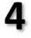

When using the logical operators, C++ only evaluates what is necessary from left to right to come up with the combined relational result, ignoring the rest. Therefore, in the last example ((5==5) || (3>6)), C++ evaluates first whether 5==5 is true, and if so, it never checks whether 3>6 is true or not. This is known as short-circuit evaluation, and works like this for these operators:

Example 1
Code | Output
//Program to check if a number is greatest among three numbers using logical && operator  int main ()  {  int a,b,c;  cout<<” enter three numbers\n”; cin>>a>>b>>c;  if(a>b && a>c) cout<<"A is greatest.\n"; else  cout<<”A is not greatest\n”; | Enter three number: 15 12 11 A is greatest
return 0;
}

Example 2
Code | Output
#include <iostream> using namespace std; int main()  {  int a = 5, b = 2, c = 6, d = 4; if (a == b && c > d)  cout << "a equals to b AND c is greater than d\n";  else  cout << "AND operation returned false\n"; | AND operation returned false  A equals to b OR c is greater than d  B is not zero
if (a == b || c > d)
cout << "a equals to b OR c is greater than d\n";
else
cout << "Neither a is equal to b nor c is greater than d\n";
if (!b)
cout << "b is zero\n";
else
cout << "b is not zero";
return 0;
}

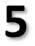

If…else Ladder
The if...else statement executes two different codes depending upon whether the test expression is true or false. Sometimes, a choice has to be made from more than 2 possibilities.
The if...else ladder allows you to check between multiple test expressions and execute different statements.

Syntax
if (test expression1) {
// statement(s)
}
else if (test expression2) {
// statement(s)
}
else if (test expression3) {
// statement(s)
}
.
.
else {
// statement(s)
}

Example 1
Code | Output
#include <iostream> | Enter two integers: 12
using namespace std; | 23
int main () { | Result: 12 < 23
int number1, number2;
cout<<"Enter two integers: "<<endl;
cin>>number1>>number2;
//checks if the two integers are equal.
if (number1 == number2) {
cout<<"Result:”<<number1<<”=”<<number2<<endl;
}
//checks if number1 is greater than number2.
else if (number1 > number2) {
cout<<"Result:”<<number1<<”>”<<number2<<endl;
}
//checks if both test expressions are false
else {
cout<<"Result:”<<number1<<”<”<<number2<<endl;
}

return 0;
}

Switch Structure:
Recall that there are two selections, or branch, structures in C++. The first selection structure, which is implemented with if and if. . .else statements, usually requires the evaluation of a (logical) expression. The second selection structure, which does not require the evaluation of a logical expression, is called the switch structure. C++’s switch structure gives the computer the power to choose from among many alternatives.
A general syntax of the switch statement is:
switch (expression)
{
case value1: statements1 break;
case value2: statements2 break;
.
.
case value n: statements n break; default: statements
}

In C++, switch, case, break, and default are reserved words. In a switch structure, first the expression is evaluated. The value of the expression is then used to perform the actions specified in the statements that follow the reserved word case. Recall that in a syntax, shading indicates an optional part of the definition.

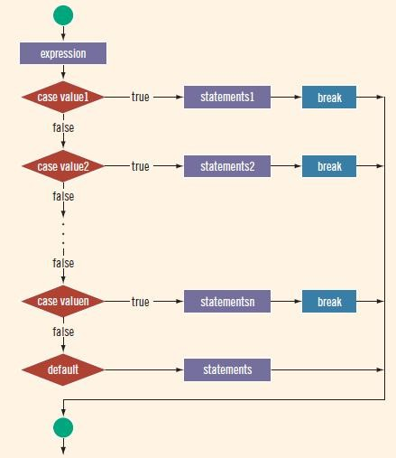
Figure 1 Switch Statement
In example 1, we use CHAR TYPE variable. It means in the CASE CRITERIA we will write ‘A’, ‘B’, etc. using COMMAS ‘ ‘ just like we declare a CHAR Type variable (For example char word= ‘C’)

Example 1
Code | Output
//Switch Example 1 #include<iostream> using namespace std; int main ()
{
char grade;
cout<<"Enter your grade: "; cin>>grade;
switch (grade)
{
case 'A':
3
cout<< "The grade point is 4.0."; break;
case 'B':
cout<< "The grade point is 3.0."; break;
case 'C':
cout<< "The grade point is 2.0."; break;
case 'D':
cout<< "The grade point is 1.0."; break;
case 'F':
cout<< "The grade point is 0.0."; break;

default:
cout<< "The grade is invalid.";
}

return 0;
}

In example 1, we use INTEGER TYPE variable. It means in the CASE CRITERIA we will write 1, 2, 3, 100, etc. without using COMMAS ‘ ‘ just like we declare an INTEGER Type variable (For example int a= 3)

Example 2
Code | Output
//Switch Example 2 #include <iostream> using namespace std; int main ()
{
int score;
cout<<"Enter your score (Max 5 Marks) : "; cin>>score;
switch (score)
{
case 0:
cout<<"Your Score is 0"; break;
case 1:
cout<<"Your Score is 1"; break;
case 2:
cout<<"Your Score is 2"; break;
case 3:
cout<<"Your Score is 3"; break;

case 4:
cout<<"Your Score is 4"; break;
case 5:
cout<<"Your Score is 5"; break;

default:
cout<< "Invalid test score." <<endl;
}
}

Loops in Programming
In computer programming, loops are used to repeat a block of code.
For example, let's say we want to show a message 100 times. Then instead of writing the print statement 100 times, we can use a loop.
That was just a simple example; we can achieve much more efficiency and sophistication in our programs by making effective use of loops.

Types of Loops
There are three types of loops in C++ as shown in the given figure:
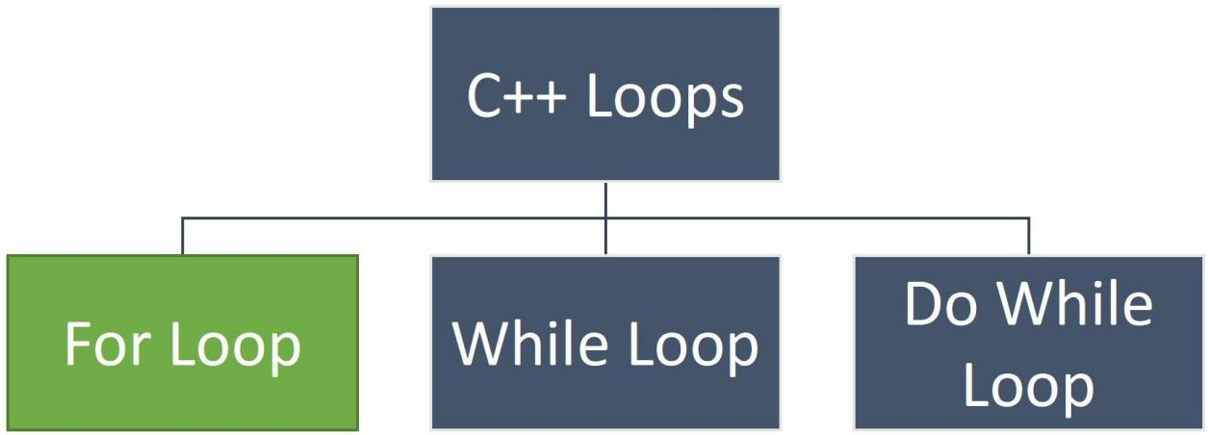
Figure 2 Types of Loops in C++

  - C++ WHILE LOOP
The syntax of while loop is as follows:
while (condition)
{
// body of the loop
}

Here,

1.
2.
3.
A
If the
loop evaluates the
evaluates to true, the code inside the
loop is executed.
The condition is evaluated again.
while
condition
condition
while

4. This process continues until the condition is false.
5. When the | condition | evaluates to | false | , the loop terminates.

Flowchart of while Loop
The given figure shows the flowchart of the while loop.
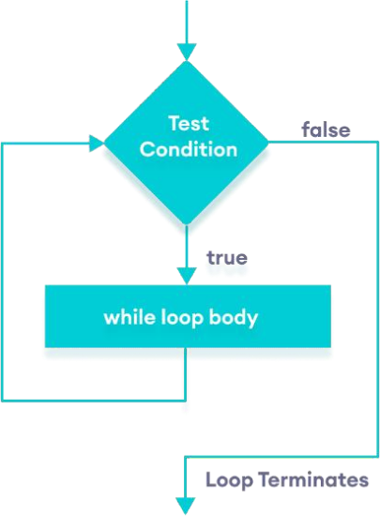

Figure 3s Flowchart of while Loop

Example
A program to print numbers from 1 to 5

Code | Output
#include <iostream>  using namespace std; int main () {  int i = 1; while(i<=5){ cout << i << " ";  ++i;  }  return 0;  } | 1 2 3 4 5
Here is how this program works:

Iteration | Variable | i <= 5 | Action
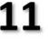

1st | i = 1 | true | 1 is printed. i is increased to 2.
2nd | i = 2 | true | 2 is printed. i is increased to 3.
3rd | i = 3 | true | 3 is printed. i is increased to 4.
4th | i = 4 | true | 4 is printed. i is increased to 5.
5th | i = 5 | true | 5 is printed. i is increased to 6.
6th | i = 6 | false | The loop is terminated

Example 2
Write a program to display Sum of positive numbers only

Code | Output
// program to find the sum of positive numbers  // if the user enters a negative number, the loop ends  // the negative number entered is not added to the sum  #include <iostream> using namespace std; | Enter a number: 6 Enter a number: 12 Enter a number: 7 Enter a number: 0 Enter a number: -2
 | The sum is 25
int main() { int number; int sum = 0;
// take input from the user cout << "Enter a number: "; cin >> number;
while (number >= 0) {
// add all positive numbers sum += number;
// take input again if the number is positive cout << "Enter a number: ";
cin >> number;
}
// display the sum
cout << "\nThe sum is " << sum << endl;
return 0;
}

In this program, the user is prompted to enter a number, which is stored in the variable |  | .
 | number

•
In order to store the sum of the numbers, we declare a variable
value of 0.
and initialize it to the
- The loop continues until the user enters a negative number. During each iteration,
the number entered by the user is added to the
variable.
- When the user enters a negative number, the loop terminates. Finally, the total sum is
displayed.
sum
while
sum

Example 3
Program to print sum of first N natural numbers using while loop in C++:

Code | Output
#include <iostream> using namespace std; int main()
{
int n, i = 1, sum = 0;
cout << "Enter number:" << endl; cin >> n;
cout << endl; while (i <= n)
{
sum += i; i++;
}
cout << "Sum N no. is " << sum << endl; return 0;
}

Lab Tasks

  - TASK 1
Smart Power Distribution System: Design a system that allows users to select appliances and evaluates their power consumption to determine efficiency levels.
Requirements
    - switch → appliance selection
    - while → repeated operation

    - if–else-if → consumption classification

Fan (Fixed Power Model)
Appliance | Condition | Power (Watts)
Fan | All cases | 100 W

AC (Temperature-Based Dynamic Power)
AC Temperature Setting | Power Consumption (Watts) | Explanation
5 (very cold) | 2000 W | Maximum cooling load
10 | 1800 W | High cooling load
15 | 1500 W | Medium-high load
20 | 1200 W | Medium load
25 | 1000 W | Low load
30 (less cooling) | 800 W | Energy efficient mode

Heater (Level-Based Power Model)
Heater Level | Power Consumption (Watts) | Explanation
1 (max heat) | 2000 W | Highest heating output
2 | 1800 W | Very high heat
3 | 1500 W | Medium heat
4 | 1200 W | Low-medium heat
5 (minimum heat) | 1000 W | Energy saving mode

Energy Calculation Rule (For All Appliances)

E = P × t
Energy Consumption (Units) | Output Label
0 – 3000 | Low power consumption
3001 – 7000 | Moderate power consumption
7001 and above | High power consumption detected

Where:

- P = power from table above
- t = user input hours

Output Classification (Standard Thresholds)

- Appliance-wise Expected Behavior Mapping

Appliance | User Input Example | System Logic Assumption (Power Model) | Expected Calculation | Expected Output Category
Fan | Hours = 5 | Low power device (e.g., 100W) | Energy = 100 × 5 = 500 | Low power consumption
Fan | Hours = 20 | Low Power Device | Energy = 100 × 20 = 2000 | Low power consumption
AC | Temp = 5,  Hours = 5 | Low temp = high load (e.g., 2000W) | 2000 × 5 =  10,000 | High power consumption  detected
AC | Temp = 20,  Hours = 5 | Medium load (e.g., 1200W) | 1200 × 5 = 6000 | Moderate power consumption
AC | Temp = 30,  Hours = 5 | Low load (e.g., 800W) | 800 × 5 = 4000 | Low / Efficient usage
Heater | Level = 1,  Hours = 5 | Max heating load (e.g., 2000W) | 2000 × 5 =  10000 | High power consumption detected
Heater | Level = 3,  Hours = 5 | Medium load (1500W) | 1500 × 5 = 7500 | High / Moderate depending threshold
Heater | Level = 5,  Hours = 5 | Lower load (1000W) | 1000 × 5 = 5000 | Moderate power consumption
Exit | Choice 4 | No calculation | System terminates | Exit message displayed

Starter Code (C++)
int main() {
//TODO starter cout section
//Student Name
//Student Roll Number #include <iostream>
using namespace std;
Starter Code (Complete the TODO sections)

// TODO Write your code here

return 0;
}

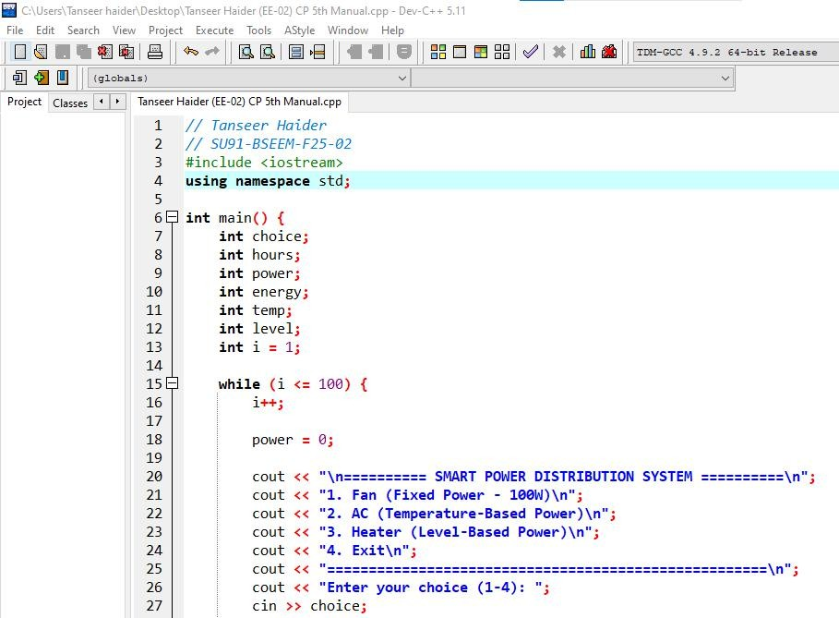

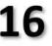

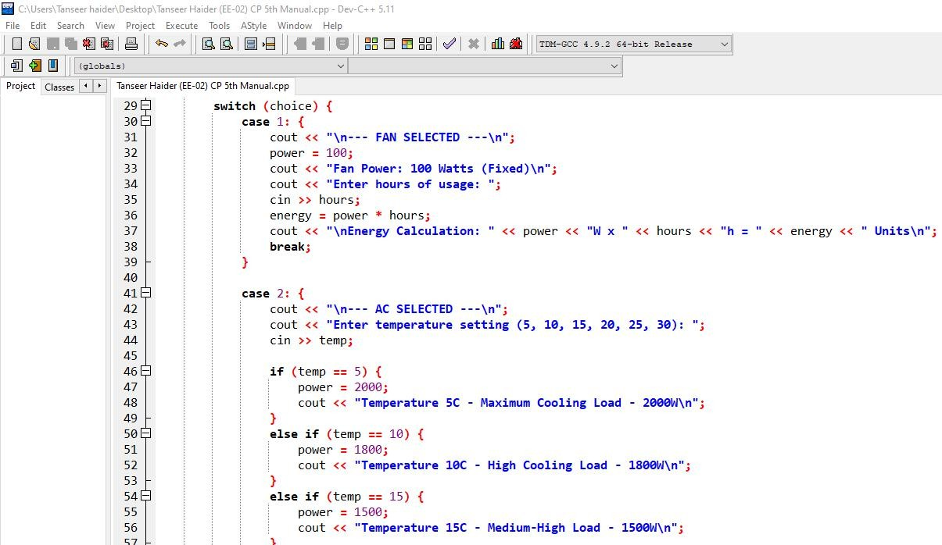

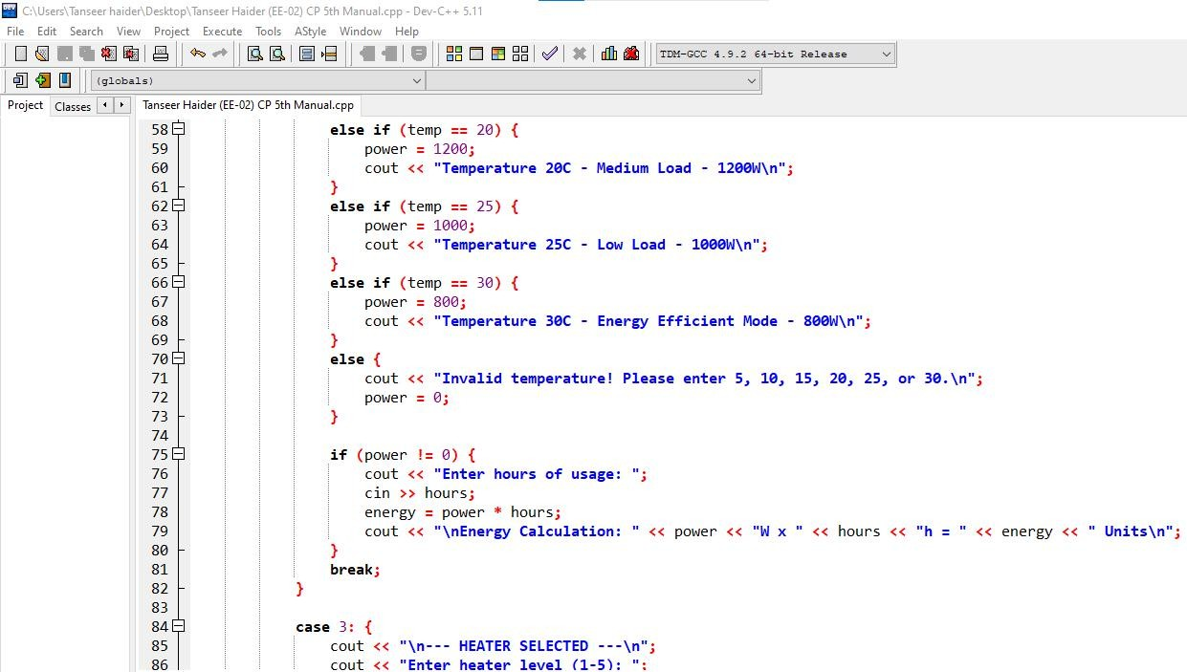



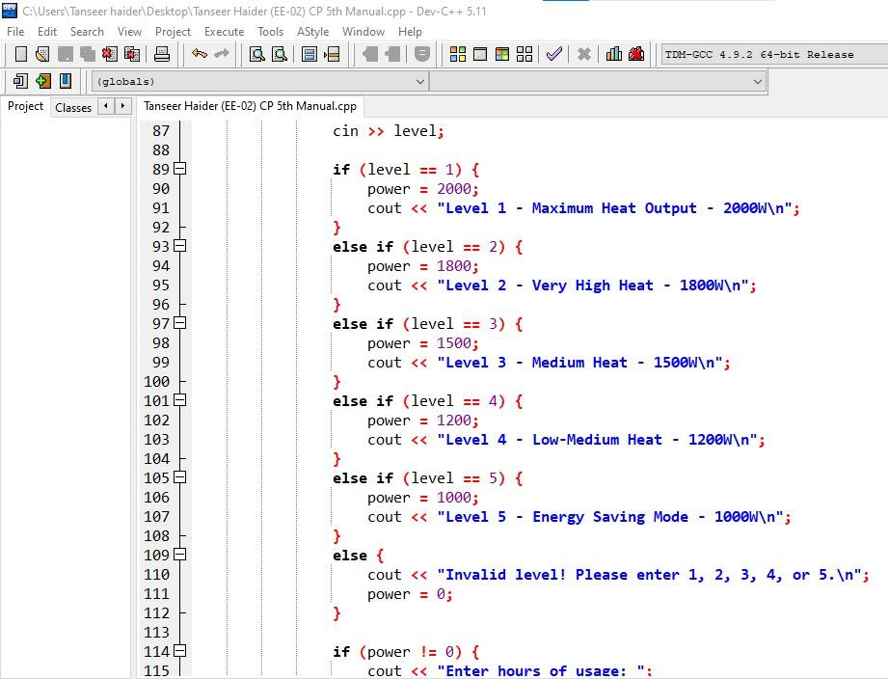
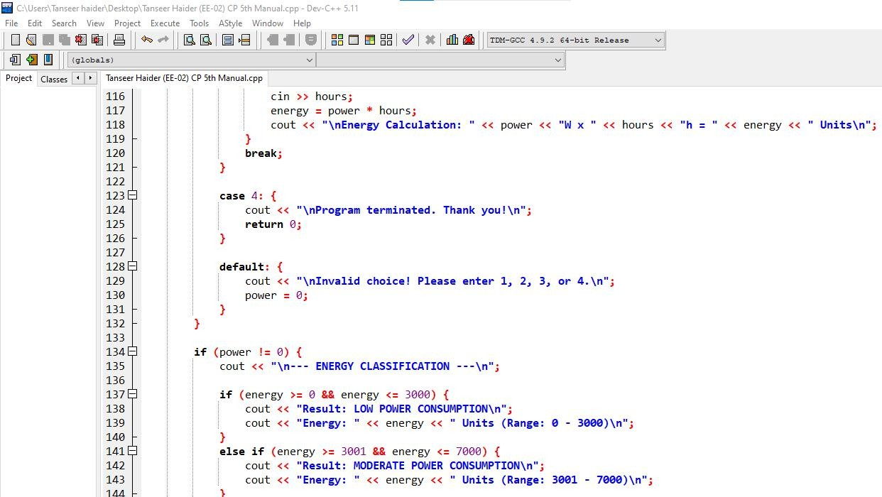
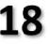

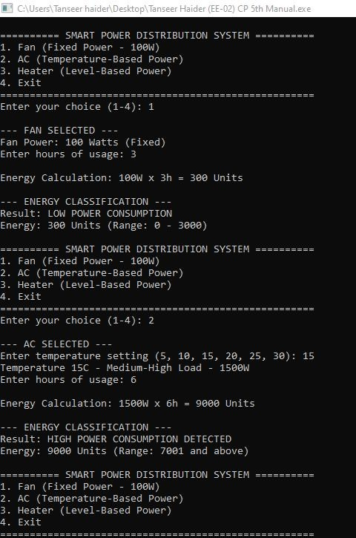



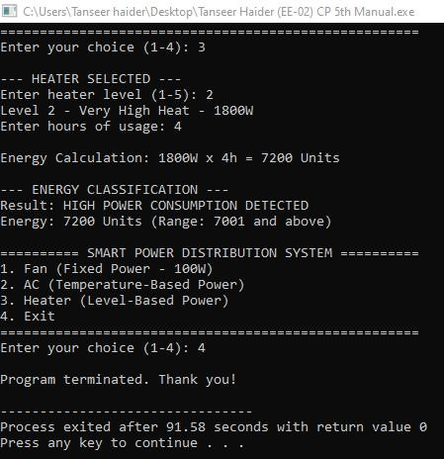

Home Assignment:

  - TASK 1
Intelligent Billing System: Develop an electricity billing system that processes multiple users and calculates bills based on tariff rules.
Requirements
    - while → repeat system until exit; multiple users
    - switch → tariff category
    - if–else-if → billing + surcharge logic
Flow Rule
- Show menu
- Take choice
- If “Calculate Bill”:
  - Input units
  - Apply slab logic
  - Compute bill
  - Show result
- Return to menu
- Exit when selected

Logic

System Control Rule (While Loop)
  - System runs continuously using a while loop
  - Menu repeats until user selects Exit

Input Rule (Single User Only)

  - System processes one user at a time
  - Inputs required:
    - User Name or ID
    - Units consumed (kWh)

Tariff Slab Rules (Core Logic)
Units Consumed | Rate per Unit
0 – 100 | 5 PKR
101 – 200 | 7 PKR
201 – 300 | 10 PKR
301+ | 15 PKR

Billing Rule (Simple Calculation)

Bill is calculated using slab condition:

  - Identify slab using if / else if
  - Then apply:

𝑖 = 𝑛𝑖𝑡 × 𝑎𝑡𝑒

Fixed Charges Rule

  - Every user must be charged:
    - 100 PKR meter charge

Surcharge Rule (Conditional Only)
Condition | Extra Charge
Bill > 3000 PKR | +10% surcharge

Final Bill (PKR) | Usage Category
0 – 1500 | Low Usage
1501 – 3000 | Normal Usage
3001 – 5000 | High Usage
5000+ | Very High Usage

Starter Code (C++)
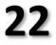
//Student Name
//Student Roll Number
Starter Code (Complete the TODO sections)

#include <iostream> using namespace std;

int main() {
//TODO starter cout section

// TODO Write your code here

return 0;
}

Expected Output
User ID: Ali
Units: 180
Rate Applied: 7 PKR/unit Base Bill: 1260 PKR Meter Charge: 100 PKR Total Bill: 1360 PKR
Status: Normal Usage
==========================================
ELECTRICITY BILLING SYSTEM
==========================================
Expected Output

